Units of Study

(See Teacher Page on School Website for tips to talk to your child about each unit)

| **1** Contact Forces | **2** Sound Waves | **3** Forces at a Distance |
| --- | --- | --- |
| **4** Earth in Space | **5** Genetics | **6** Natural Selection and Common Ancestry |

Grading

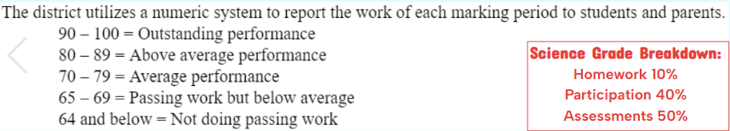

Absent Work

Students will have 2 days for every day absent to make up work. Students may utilize Google Classroom to begin absent work if able. Students are expected to retrieve absent work from the Absent Work Area upon returning to school. If a child is present leading up to a test, but absent on test day, the student should be ready to take the test upon returning to school. If a child is absent leading up to a test, the student should see the teacher to schedule a make-up test. See teacher if extensions are needed or to stay after school to make up work.

Late Work

| **Homework** | Students have up to 1 week to turn in late homework for ½ credit. Homework will NOT be accepted past 1 week late.  Homework is ALWAYS posted on Google Classroom with the due date and can be done on regular paper if forgotten at school. |
| --- | --- |
| **Classwork**  (Participation) | Students shall complete all unfinished classwork by the next class. Weekly participation grades will be lowered by 5 points for each missing assignment. |
| **Assessments** (Tests, Quizzes, Graded Classwork) | Students will lose 5 points for each day a graded classwork assignment is late.  Test and quiz grades will appear as Missing in Genesis (zero points) until made up, but no points will be removed from tests or quizzes taken after the assigned date. |

Cell Phones

Cell phones and other electronic devices are to be off and away. Any cell phone taken out without permission will be placed in the cell phone caddy until the end of class.

Discipline & Late to Class

| **1st Infraction** | **Warning: Behavior Reflection Sheet** |
| --- | --- |
| **2nd Infraction** | **Phone Call Home, Signed Behavior Reflection Sheet** |
| **3rd Infraction** | **Teacher Detention After School & above** |
| **4th Infraction** | **Write-up & above** |

Be Prepared

Students are required to bring their science binders and pencils to class daily. Students will not be permitted to go to their lockers after the class bell rings. Binders should be kept up to date. Table of contents is always updated on Google Classroom so students can access it. Binders are a tool and can be used to complete all assessments.

Speak Up

Our science class relies on effective communication between students and the rest of the class. Don’t be afraid to share your thoughts and answers. Just like in the real science community, mistakes are expected, respected, inspected, and corrected.

Extra Help

Students that want to stay after school for help or to make up work may see Ms. Hughes to schedule a day to stay after Monday - Thursday. Students will take the 4:20pm late bus home or may be picked up by a parent/guardian prior to 4:10pm. All students not picked up by 4:10pm will be put on a late bus.

Let’s have an amazing year Lions!!!

